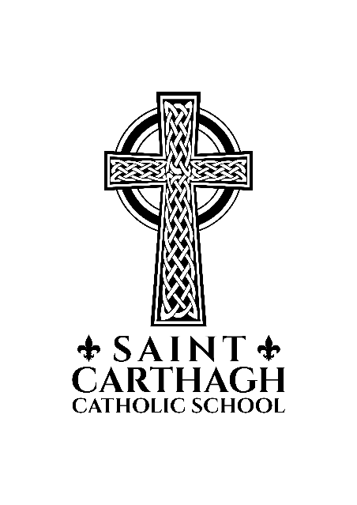

ST. CARTHAGH CATHOLIC SCHOOL
DECEMBER UPDATE

Theme for December-Hope (Catholic Graduate Expectation-A Discerning Believer)

School Communication – A reminder for parents to please check our webpage often as most communication will be posted there ( www.alcdsb.on.ca/school/cart ). We also encourage you to subscribe on the webpage to receive our Monthly Updates by email. We want to keep you up to date on all of the good things happening here!

School Mass-Please join us on December 13th at 9:30 for Mass at the Church.

Together is Better-Please join us on December 29th at 9:45 for our Together is Better assembly.

Donations needed for Christmas Shopping-Gently used household items, toys, Christmas wrapping paper, gift bags, scotch tape and gift tags wanted! These items will be used at the St. Carthagh Christmas shopping event on December 13th. Students are invited to purchase gifts for their family members, wrap them and take them home with pride! All items are $1(to ensure that all students have the opportunity to make purchases, we limit the number of gifts to four per student). Donations accepted until December 12th. Volunteers needed on December 13th to assist ‘shoppers’ and for wrapping, etc.

Student Confessions-Father Aidan will hear confessions for students in Grades 3-8 on December 12th starting at 9:45.

Skating-Gr. 1-8 students will go skating on December 17th from 10:00-12:00 (2 groups). Helmets are mandatory to be on the ice. Students will walk to the Tweed Arena. In the spirit of Christmas, the Municipality of Tweed-Parks & Rec Department generously donated the ice time-thank you!!

Christmas Sharing-St. Carthagh Catholic School staff & students plan to provide 7 Christmas Sharing baskets for those in need. More information will come home soon. Please support this worthwhile cause.

Christmas Concert-We invite everyone to join us as we celebrate this Holy Season on December 11th at 6:30 p.m.

Christmas Dinner-On December 16th students will be treated to a wonderful Christmas dinner. Our thanks to School Council for providing this opportunity. The school will provide juice for each student. Students are asked to bring a plate, fork and butter knife in a Ziploc bag.

Piano Recital-Students of Mrs. Donna Broek will be performing an annual Christmas Piano Recital on December 18th at 6:30 p.m. All are welcome.

Congratulations!-All of our Volleyball teams did very well in the ALCDSB tournaments. Our Junior co-ed team placed 1st and out Senior Girls are heading to St. Theresa’s this Wednesday at 5:00 to play in the finals against Holy Rosary. Thanks for your coaching Mrs. Campbell, Mrs. Gunter and Ms. Robertson!

 | December 2019
Sun | Mon | Tue | Wed | Thu | Fri | Sat
1  Advent Begins | 2  12 Days of Christmas Draw Starts | 3 | 4  Kindergarten Trip to Tree Farm | 5  Gr. 8 Parent Information Night  St. Theresa 6:30 | 6 | 7  Santa Claus Parade
8 | 9 | 10  MADD Presentations | 11  Christmas Concert 6:30-Doors Open 6:00 | 12  Student Confessions | 13  Christmas Shopping  School Mass 9:30 | 14
15 | 16  Christmas Dinner | 17  Skating 10:00-12:00 Gr. 1-8  12 Days of Christmas Draw Ends | 18  Mrs. Broek’s Piano Recital 6:30 | 19 | 20  Together is Better Assembly 9:45 | 21
22 | 23  Christmas Holidays Begin | 24 | 25 | 26 | 27 | 28
29 | 30 | 31

